
TARGET PRIVATE SECONDARY SCHOOL

2026 JCE MOCK EXAMINATION
PHYSICS
Thursday, 2nd April Subject Number: J164
Time Allowed: 2Hours
8:00am – 10:00am
(100 marks)
Question number | Tick if answered Qs 1 to 20 | Do not write in these columns
1-20
21
22
23
24
25
26
27
28
29
30
31
32
33
Instructions
- This paper contains 10 printed pages. Please check!

- Write your full name on top of every page.

- Answer all questions in the space provided.

- There are three sections A,B and C. Answer all questions in all sections

- In the table provided on this page, tick against the question number you have answered.

Section A: 20 marks
Answer all questions in this section by encircling the correct answer.
- A student wants to find out the effect of temperature on the solubility of sugar in water. The independent variable is
- Solubility of sugar
- Temperature
- Time taken
- Materials used
- Liquids and gases have the same property in which both
- cannot be compressed
- can flow
- have fixed volume and shape
- have equal intermolecular forces
- What would be the best laboratory safety measure to be followed when a student observes some loose wires in a laboratory?
- Tighten the wires
- Switch off electricity
- Inform the teacher
- Use plastic gloves remove the wires
- Which of the following energy changes takes place when a brick layer falls from a scaffold?
- Kinetic potential heat + sound
- Potential kinetic heat + sound
- Chemical kinetic heat + sound
- Chemical kinetic potential

- Which of the following is the characteristic of an image formed on a pinhole camera?
- upright
- lateral inverted
- up-side down
- virtual
- The bending of light as it passes through a media of different densities is called?
- dispersion
- diffraction
- refraction
- reflection
- A mango of mass 250g fall from a tree to the ground with a speed of 8m/s. The height in which the mango fall is
- 8.0m
- 4.0m
- 3.2m
- 0.25m
- Converting 1000cm² to m² it becomes
- 10⁻¹ m²
- 10⁻² m²
- 10⁻³ m²
- 10⁻⁴ m²

- Two forces are acting on a box in which 20N and 40N are due west and 35N is due east. The resultant force is
- 15N due east
- 25N due west
- 5N due west
- 25N due east

- A cube of dimension 2cm weighs 16g. The density of the cube is
- 2g/cm³
- 4 g/cm³
- 8 g/cm³
- 32 g/cm³
- Which of the following is an effect of balanced forces?
- An object start moving
- An object increases in speed
- An object stays at rest
- An object bends
- The instrument that is only used to measure the resistance of the conductor is
- Ohmmeter
- Ammeter
- Voltmeter
- Multimeter
- The following are the methods of studying physics except,
- experimentation
- observation
- expert opinion
- hypothesis

- Figure 1 is a diagram showing an instrument that is used to measure force.
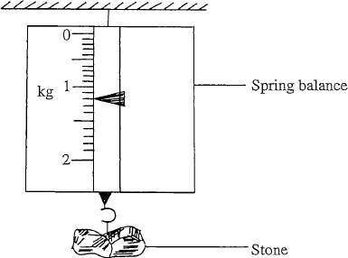

What is the weight of the stone?
- 1.2N
- 12N
- 120N
- 1200N

- Which of the following energy is correctly matched with its source
- Solar energy - wind
- Tidal energy - sun
- Geothermal – steam from the ground
- Nuclear energy – dead living organisms
- The S.I Unit of moment of force is
- joule
- newton-meter
- newton
- meter
- An atom x has a mass number of 35 and atomic number of 17. The charge number of the atom is
- 18
- 35
- 17
- 52
- What is the number of images formed when two mirrors are placed at an angle of 60⁰C?
- 5
- 6
- 7
- 8
Figure 2 shows particles of water changing from solid to liquid state. Use it to answer question 19 and 20.

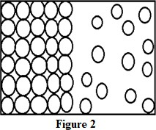

- What is the process represented by the arrangement in the diagram above?
- Solidification.
- Sublimation.
- Deposition.
- Melting.
- At what temperature does water undergo the process represented in the diagram above?
- 373K
- 100K
- 273K
- 0K

Section B: 50 marks
- (a) Define electric current
______________________________________________________________________________________________________________________________________________________
(1 mark)
(b) Describe the differences in terms of directional flow between electric and convectional current
______________________________________________________________________________________________________________________________________________________
(2 marks)
(c) Explain why is it important to use a fume chamber in the laboratory.
_________________________________________________________________________
(1 mark)
- (a) State two differences between weight and mass
______________________________________________________________________________________________________________________________________________________
(2 marks)

(b) Explain how roughness and smoothness of the surface area affect frictional force
______________________________________________________________________________________________________________________________________________________
(2 marks)
(b) Give any one way in which frictional force can be minimized
___________________________________________________________________________
(1 mark)
- Figure 3 shows the lever system.
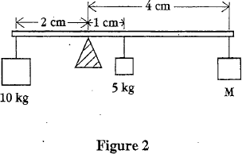
For the lever to balance, what should be the value of mass M?

(5 marks)
- (a) Define radioactivity
____________________________________________________________________________________________________________________________________________________________
(1 mark)
Figure 4 below shows a deflection of radiation in an electric field.
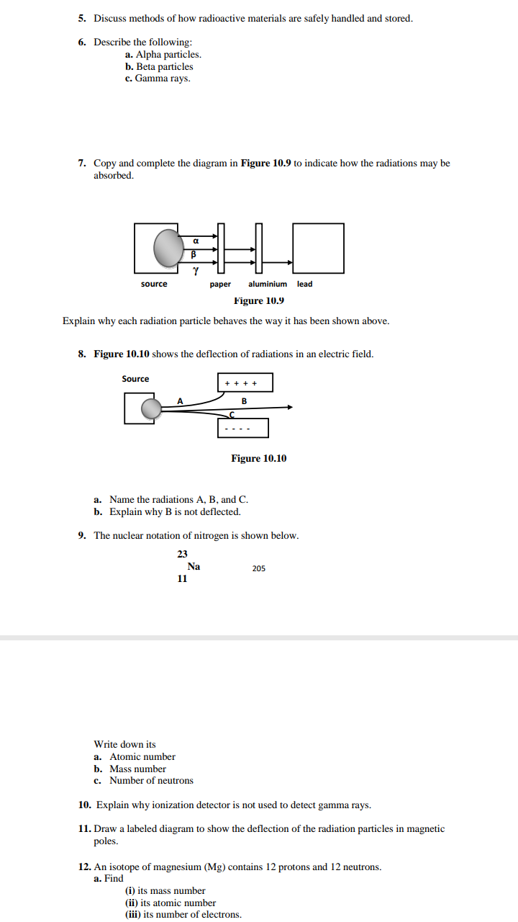
(b) Name the radiations A, B and C.
A_________________________________________________________________________B_________________________________________________________________________C_________________________________________________________________________
(3 marks)
(c) Explain why B is not deflected
___________________________________________________________________________
(1 mark)
- (a) Define isotopes.
______________________________________________________________________________________________________________________________________________________
(1 mark)
Table 1 shows atomic number and number of protons, of neutrons of atoms W, X, Y, Z which are not the real symbols.

 | W | X | Y | Z
Atomic number | 6 | 7 | 6 | 8
Number of neutrons | 8 | 7 | 6 | 8

(b) Identify the atoms that are isotopes.
______________________________________________________________________________
(2 marks)
(b). Give a reason why the atoms in Q25 (b) are isotopes.
______________________________________________________________________________
(1 mark)
- (a) Kauvi primary school is 4200m above sea level. What is the boiling point of water at that school

(3 marks)
(b) Explain clearly how the lateral inversion in a periscope is cancelled
__________________________________________________________________________________________________________________________________________________________________________________________________________________________________________
(2 marks)
- (a) Describe the anomalous behaviour of water that occurs from 4⁰C to 0⁰C.
__________________________________________________________________________________________________________________________________________________________________________________________________________________________________________
(3 marks)
(b) Explain why Illala ship floats on water while a nail sinks in water.
____________________________________________________________________________________________________________________________________________________________
(2 marks)
- (a) Why is water considered as a very good body temperature regulator?
____________________________________________________________________________________________________________________________________________________________
(2 marks)
(b) Calculate the heat energy required by a kettle to raise the temperature of 2kg of water by 10⁰C. (Specific heat capacity of water is 4200 J / Kg ⁰C)

(3 marks)
(c) If the kettle has used the electric energy for 2 minutes, calculate the power needed by the kettle

(2 marks)
- (a) Define work
______________________________________________________________________________________________________________________________________________________
(1 mark)
(b) Figure 5 below is a diagram of an instrument that is used to measure voltage.
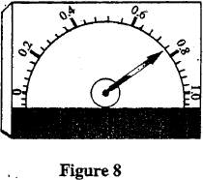
Calculate the voltmeter reading

(4 marks)
- (a) Give any two uses of pulley system in our everyday life.
______________________________________________________________________________________________________________________________________________________
(2 marks)
(b) Explain how can effort can be reduce reduced in levers
______________________________________________________________________________________________________________________________________________________
(1 mark)
(c) State any two ways in which experimental data can be represented
______________________________________________________________________________________________________________________________________________________
(2 marks)
Section C: 30 marks
- a Describe an experiment that can be done to determine the density of irregular substance
__________________________________________________________________________________________________________________________________________________________________________________________________________________________________________________________________________________________________________________________________________________________________________________________________________________________________________________________________________________________________________________________________________________________________
(5 marks)
b. Describe an experiment that can be done to show thermal expansion in solids by using a ball and ring apparatus.
__________________________________________________________________________________________________________________________________________________________________________________________________________________________________________________________________________________________________________________________________________________________________________________________________________________________________________________________________________________________________________________________________________________________________
(5 marks)
- a. With the help of a well labeled diagram, describe an experiment that can be done to show the effect of increasing number of bulbs in series circuit on the brightness of the bulb.

____________________________________________________________________________________________________________________________________________________________________________________________________________________________________________________________________________________________________________________________________________________________________________________________________________________________________________________________________________________
(5 marks)
b. Describe the procedure that can be done to determine the north-pole and south-pole of a bar magnet.
________________________________________________________________________________________________________________________________________________________________________________________________________________________________________________________________________________________________________________________________________________________________________________________________________________________________________________________________________________________________________________________________________________________________________________________________________________________________________________
- marks)
- (a) With the help of a well labelled diagram, describe how a periscope works

__________________________________________________________________________________________________________________________________________________________________________________________________________________________________________________________________________________________________________________________________________________________________________________________________________________________________________________________________________________________________________________________________________________________________
(5 marks)
b. Construct an electric circuit in which 2 cells are arranged in parallel, 2 bulbs in series, an open switch such that the bubs does not give light and a fuse.

(5 marks)
END OF QUESTION PAPER

